**Set of BMS consist of:**

BMS motherboard 1set   
 Screen 1set   
 Screen line wiring 1pcs   
 Screen line power cord 1pcs   
 Battery temperature sensor 4pcs.   
 Motherboard boot button 1pcs.  
 Battery connection cable 25pcs   
 Two battery pack connectors  
 **Dimensions:  L 160 x W 72 x H 30mm**  
Picture below:  
  
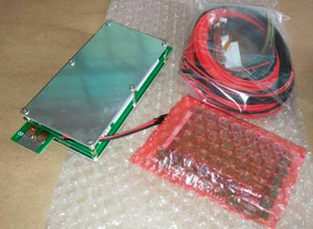

From stock by default are available options of BMS:   
 24S BMS with LCD screen (configurable via Android Apps).   
 32S BMS with LCD screen (configurable via Android Apps).  
  
Peak discharge current 300A *( is possible to reduse/change this and other parameters ).*   
This BMS is suitable for Li-ION / LFP / LTO (configurable).  
 **Price:                                              55000 €/pcs. netto   
Price for partners with discount -25% 41250 €/pcs. netto**

**INTRODUCTION**

*This product is very suitable for electric bicycles, electric motorcycles, electric cars and UAV lithium battery  management, Very powerful management system BMS, suitable for all lithium battery (3.2V, 3.6V, 3.7V), Bluetooth phone connection APP setting parameters.*

**Note: This product is suitable for those who have some technical knowledge of electronic purchase, if you know nothing about, please do not buy.**

Maximum discharge current: 300A

Maximum charge current: 100A

The protection voltage of the battery can be set freely

1. Protection board to support any of the battery within the string of 24 (lithium titanate, iron lithium, ternary, etc.) (supply voltage is greater than 24v)

2. Battery cell voltage detection, the voltage detection range 1-5v (less than 1v and can not be detected than 5v), high precision, the integrated error is less than 5mv, for all voltage within the range of battery pack, overshoot Protection, over-discharge protection voltage can be arbitrarily set in this range.

3. Using a controlled equalization mode, the charge can be detected by the pressure is greater than the set value after the start balance. Current measurement (current measurement within 300A)

4. Coulomb meter function, based on the current time integral, accurate calculation of battery capacity, charge power and so on.

5. Support Android phone set different battery parameters, view the voltage and current information

6. Support the screen display battery pack status, parameters, each section of the single voltage

7. Based on motor Hall pulse detection speed, and can calculate the remaining life mileage

8. Independent 6-channel temperature measurement, you can set the temperature over-temperature protection value

9. Independent watchdog real-time monitoring program, never crash!

**NOTE**

Protection board wiring and sensitive to fragile, every step of the wiring are carefully checked, not sloppy, each step must be well insulated to prevent any short-circuit possible! (There are a lot of careless customers short-circuit burned board) The battery's temperature sensor needs to be placed inside the battery pack so that the battery pack temperature can be better tested. At the same time, please do the temperature sensor insulation. Otherwise, any consequences caused by the customer at their own expense.

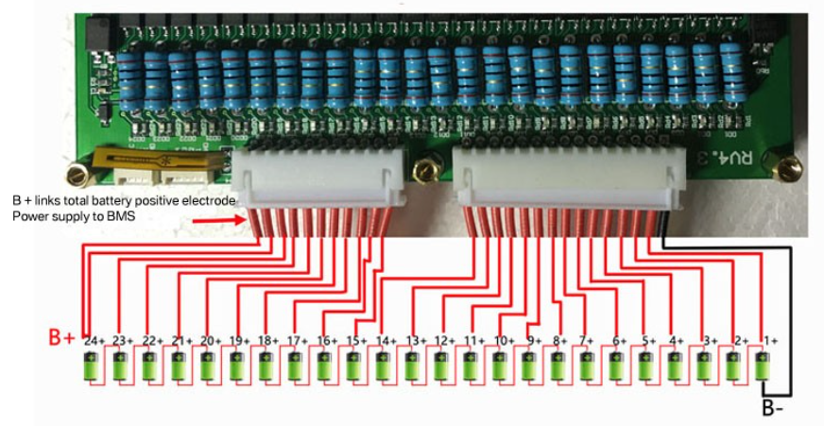

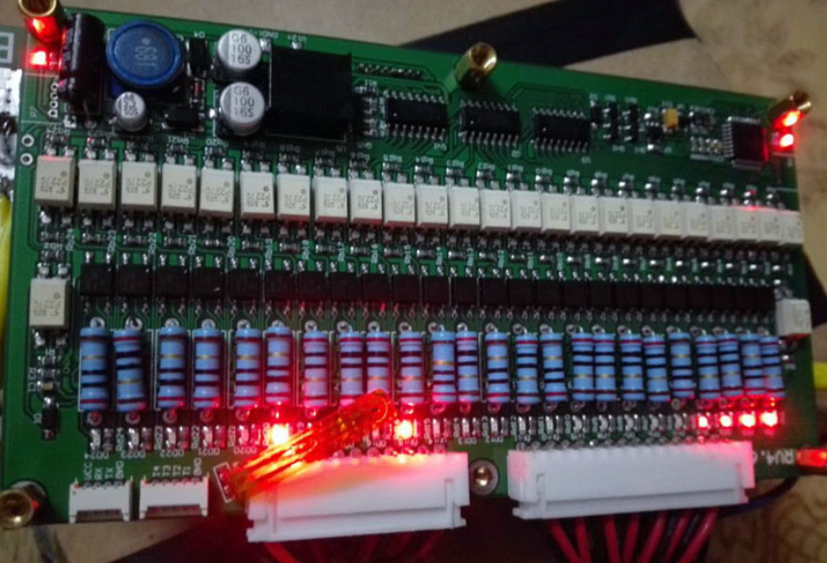

**MOTHERBOARD TEST**

After receiving the goods, please do not hurry to link the battery, please remove the motherboard screws, carefully check the inside of the port name.

1．the distribution of small key switches and joints welding.

2．then reassemble the motherboard. Do not connect the battery in the case of the motherboard decomposition, so that the permanent damage to the motherboard

3．the following figure is the test board to connect the battery the most simple wiring diagram.

4．motherboard power supply voltage: 18V ~ 100V (many customers can not start the motherboard, because the motherboard input voltage is too low)

5．Start the motherboard: the need to link the line to complete, hold down the small switch for 3 seconds, until the motherboard red light, release the switch.

6．Off the motherboard:

1, hold down the boot switch for about 5 seconds, release the switch, the motherboard display lights go out; the

2, the phone APP link motherboard, click APP on the button to close the motherboard.

7．If the motherboard is successful, please disconnect the power supply. The battery balance line into the motherboard, the display can be displayed on the battery pack voltage. The battery equalizer line must be checked to see if the connection is correct, if not correct, directly connected to the motherboard, the motherboard will cause damage. )

The following picture is the simplest motherboard connection.

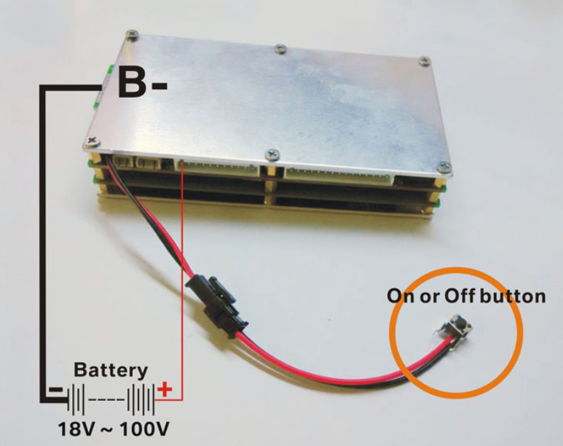

**ON OR OFF BUTTON DESCRIPTION**

1. Protection board if it is abnormal power off caused by the shutdown, just a short press to start BMS normal work;

2. Protection board normal work, long press this button for more than 5 seconds, then release the button, the protection board will automatically turn off the power, stop working, no power consumption. Boot case, short press can be achieved to switch the protective board matching screen display.

3. Protection board If the discharge tube is not open more than 5 minutes, the protection board will automatically turn off the total power, stop working, zero power consumption.

4. If the BMS power is turned off for the purposes of Article 2 and Article 3, you need to press the power button for 3 seconds to make the protection board work normally.

5. If the matching display is connected, press this button briefly to switch the screen display.

6. Power button to ensure good insulation, otherwise, may not be able to automatically turn off the BMS power supply.

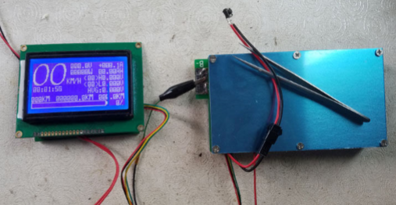

**WIRING INSTRUCTIONS**

Temperature sensor and balanced wiring:   
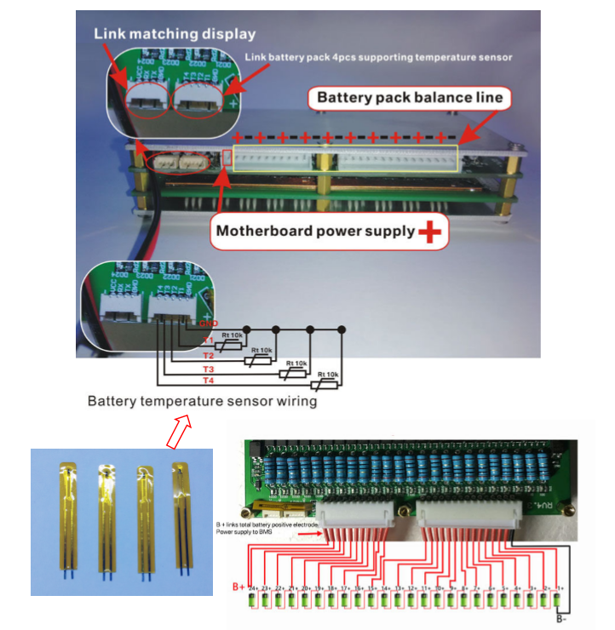  
 **21S CONNECTION EXAMPLE**

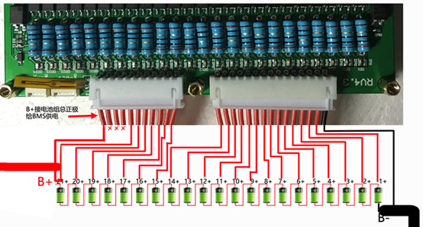

**BOARD OUTPUT AND CHARGING WIRING**

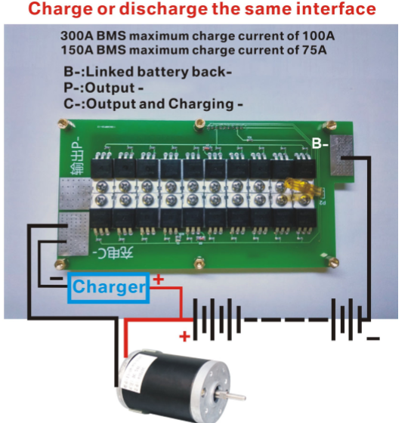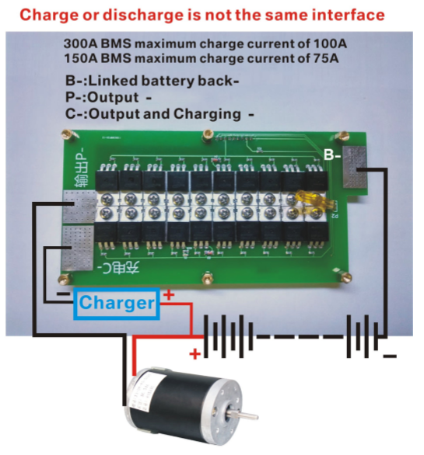

Because the **P-** is extremely easy to damage the power tube, the latest version has not   
printed the **P-** name, however users need to use, you can choose the P- output.

**DISPLAY DESCRIPTION**

